Transport robots in reality

# Neobotix

http://www.neobotix-robots.com/transport-systems.html

The big difference to traditional automatic guided vehicles (AGVs) is that transport robots can react dynamically to unexpected changes of their surrounding.

* 2D laser scanners that permanently detect landmarks and obstacles around the robots
  + allows the robots to move around without any fixed path markings or other installations
  + enables them to safely operate between humans and other moving obstacles
* flexibility and capability to autonomously handle unpredicted obstacles makes our transport robots perfectly suited for dynamic transportation tasks with frequent changes
* They can complement stationary transport systems, like roller or belt conveyors, and take parts to machines or workplaces that for some reasons are not connected to the main conveyors.

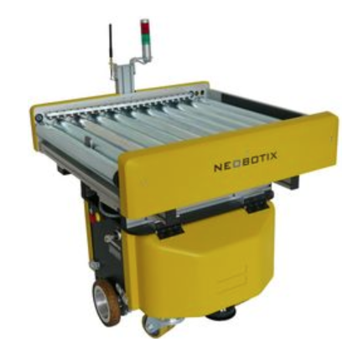

Possible applications are:

* Taking samples to and from testing machines
* Taking parts to manual workplaces in small batch production
* Transport in direct interaction with humans
* Dynamic picking of parts for later assembly

Possible implementations:

* automatic way finding
* obstacle avoidance

# SMP robotics

https://smprobotics.com/application_autonomus_mobile_robots/transport-robots/

*Since the early days of human civilization, one of the most critical problems has been* *transportation. While today trucks transport cargos over thousands of miles, light items are still being carried in wheelbarrows or trailers attached to compact tractors or ATVs. Such a solution may seem appropriate but not in the case of repeated passages to a specific location or in the case of travelling for only few miles, for example, removing of grass clippings and fallen leaves, construction debris removal, and garbage collection.*

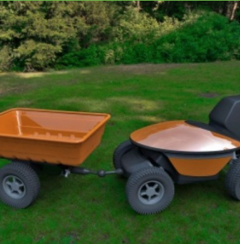

Small-sized transport robots are equipped with electric engines that ensure noiseless operation without any exhaust smell, which allows for operation that is not disturbing to people around. Reserved energy stored in build-in accumulators can last for dozens of miles of cyclical operation.

**There are two ways to program the robot’s route map. First, a route can be selected on a digital map by using a PC tablet attached to the robot. The second way is to walk in front of the robot on a desired route. The robot moves behind an operator in the ‘follow me’ mode and compiles a digital map for future autonomous navigation.**

A trailer for transportation of bulk goods has a side dropping mechanism to allow automatic unloading without an operator’s intervention. A trailer fitted with a water tank is suitable not only for water transportation but also for watering grass and other plants.

Possible implementations:

* predefined route vs follow me mode and mapping

# Military transportation robots

<http://www.allonrobots.com/military-transportation-robots.html>

By putting humans to this work they are often exposed to a risk that could be avoided. I'm not talking only about people that carry things around in a backpack - more about the drivers that have to drive into dangerous areas.

## Autonomous Platform Demonstrator

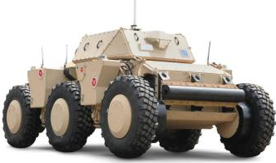

It has a hybrid-electric drive train with six in-hub electric motors powered by li-ion batteries charged using an on-board diesel generator. The APD is a skid steer vehicle that can pivot-turn in place. Other technologies include a lightweight hull, an advanced suspension system, and others.

From control point of view it can be controlled in real-time by a soldier or it can operate autonomously. Autonomously it can operate at speeds up to 50 mph. It can travel along a GPS way point route and avoid obstacles in its way.

**R-gator**

So, it can be remote controlled using an xbox 360 controller (I am not joking). It can move autonomously along a preprogrammed route using GPS. And it can still be driven by a driver. The switching between these modes can be done as easily as switching a switch.

It can be used to remotely inspect areas of interest. It can autonomously patrol and send a video stream back to the command center. It can be used to ensure safe extraction of causalities and to transport cargo. This is not limited of course.

Possible implementations:

* remote control
* route following
* overcome road obstacles and navigate on steep slopes

# **BMW Logistics Now Use Autonomous Transport Robots**

<http://www.bmwblog.com/2016/11/18/bmw-logistics-now-use-autonomous-transport-robots/>

BMW has been working hard to reduce emissions in all steps of the manufacturing process of a car, not only in the final product.

Autonomous driving seems to be the next big thing in the auto industry but while it will certainly be helpful on the road, it can also help out in the manufacturing process. An initial fleet of ten self-driving Smart Transport Robots (STR) is transporting components through logistics at the Wackersdorf plant. What is unique is that the self-driving transport robot does not need floor-mounted induction loops for navigation, but moves freely through the logistics hall, powered sustainably by pre-used batteries from the BMW i3 and is able to transport containers weighing up to 500 kilograms.

The STR measures the distance to wireless transmitters to calculate its exact position and route. Using sensors to identify and react to critical situations, it is able to share the route with humans and other vehicles. After five months of prototype operation, the project will be transferred to pre-series production, where the ten STRs will be used for the first time in everyday operations and perform transport assignments independently. In the next phase of development, a 3D camera system will enable even more precise navigation.

Possible implementations:

* odometry: wireless transmitters to calculate exact positions and route